**VISVESVARAYA TECHNOLOGICAL UNIVERSITY**

**JNANA SANGAMA, BELGAVI – 590014**



**A MINI PROJECT REPORT ON**

**THE NIFTY 10**

**IN**

**COMPUTER SCIENCE & ENGINEERING**

**By**

| **1DB20CS035** | **Dev H Gowda** |
| --- | --- |
| **1DB20CS038** | **Divya S Mavinakai** |

**Under the Guidance of**

**Hemanth Kumar N P**

**Assistant Professor**

**Department of CSE, DBIT**



**DEPARTMENT OF COMPUTER SCIENCE & ENGINEERING**

**DON BOSCO INSTITUTE OF TECHNOLOGY**

**BENGALURU – 560074, KARNATAKA**

**2022 – 2023**

**DON BOSCO INSTITUTE OF TECHNOLOGY**

**BENGALURU – 560074, KARNATAKA**

**DEPARTMENT OF COMPUTER SCIENCE & ENGINEERING**



**CERTIFICATE**

This is to certify that the Mini Project entitled **“THE NIFTY 10”** has been successfully completed by Dev H Gowda(1DB20CS035) & Divya S Mavinakai(1DB20CS038) the bonafide students of the **Department of Computer Science & Engineering, Don Bosco Institute of Technology** of the **Visvesvaraya Technological University, Belagavi – 590014**, during the year 2022–2023. It is certified that all corrections/suggestions indicated for Internal Assessment have been incorporated in the report deposited in the departmental library. The Mini project report has been approved as it satisfies the academic requirements in respect of the Mini Project work prescribed for the Bachelor of Engineering Degree.



**Hemanth Kumar N P Dr. K B Shiva Kumar**

**Mini Project Guide HOD CSE**

**External Viva**

**Name of the Examiners Signature with Date**



**DON BOSCO INSTITUTE OF TECHNOLOGY**

**BENGALURU – 560074, KARNATAKA**

**DEPARTMENT OF COMPUTER SCIENCE & ENGINEERING**



**Declaration**

We, **Dev H Gowda, Divya S Mavinakai** hereby declare that the dissertation entitled, **THE NIFTY 10** is completed and written by us under the supervision of my guide **Hemanth Kumar N P,** **Assistant Professor, Department of Computer Science and Engineering, Don Bosco Institute of Technology, Bengaluru**, of the **Visvesvaraya Technological University, Belagavi - 590014,** during the academic year 2022-2023.The dissertation report is original and it has not been submitted for any other degree in any university.

**Dev H Gowda 1DB20CS035**

**Divya S Mavinakai 1DB20CS038**

**ACKNOWLEDGEMENT**

The satisfaction and euphoria that accompany a successful completion of any task would be incomplete without the mention of the people who made it possible, success is the epitome of hard work and perseverance, but steadfast of all is encouraging guidance.

So, with gratitude, we acknowledge all those whose guidance and encouragement served as beacons of light and crowned the effort with success.

The selection of this mini-project works as well as the timely completion is mainly due to the interest and persuasion of our mini-project coordinator Mr. **Hemanth Kumar N P,** Assistant Professor, Department of Computer Science & Engineering. We will remember his contribution forever.

We sincerely thank, **Dr. K B Shiva Kumar**, Professor, and Head, Department of Computer Science & Engineering who has been the constant driving force behind the completion of the project.

We thank our beloved Principal **Dr. B S Nagabhushana,** for his constant help and support throughout.

We are indebted to the **Management of Don Bosco Institute of Technology, Bengaluru** for providing an environment that helped us complete our mini project.

Also, we thank all the teaching and non-teaching staff of the Department of Computer Science & Engineering for the help rendered.

Dev H Gowda 1DB20CS035

Divya S Mavinakai 1DB20CS038

**ABSTRACT**

The NIFTY 10 web application is a data management tool that focuses on the top 10 stocks of the Indian stock market. The NIFTY index, which is maintained by the National Stock Exchange of India, is a market capitalization-weighted index of 50 of the largest publicly traded companies in India. The NIFTY 10 application provides users with real-time data on the top 10 stocks of the NIFTY index, including stock prices, trading volumes, and other financial metrics.

Users can also access historical data and charts of the top 10 stocks, as well as financial news and analysis. This allows users to track the performance of the top 10 stocks over time and make informed investment decisions. The app also offers portfolio management tools, so users can track their own investments in the top 10 stocks and monitor their performance. This way users can also compare their portfolio with the top 10 stocks and make adjustments accordingly.

Additionally, users can set up alerts for important events, such as dividends or stock splits, to stay informed of any changes in the top 10 stocks. This way users are always up-to-date with the top 10 stocks and can make timely decisions. The NIFTY 10 web application also provides users with the option to customize their watchlist, so they can focus on the stocks that are most relevant to them.

The NIFTY 10 web application also provides users with a range of analysis tools such as technical analysis, fundamental analysis and stock screener. This way users can make informed decisions by analyzing the stocks using different metrics. Users can also compare stocks using the comparison tool to find the best stock to invest in.

In summary, The NIFTY 10 web application is a comprehensive data management tool that provides real-time data and analytics on the top 10 stocks of the Indian stock market. It offers a range of features such as real-time stock prices, historical data, portfolio management, analysis tools and comparison tools which enables users to make informed decisions and stay updated on the top 10 stocks of India. This application is a valuable resource for anyone who wants to invest in the top 10 companies of India and monitor their performance.

**TABLE OF CONTENTS**

| **CHAPTER NO.** | | | | **DESCRIPTIONS** | | **PAGE NO.** | | |
| --- | --- | --- | --- | --- | --- | --- | --- | --- |
|  | | | | **DECLARATION** | | **I** | | |
|  | | | | **ACKNOWLEDGEMENT** | | **II** | | |
|  | | | | **ABSTRACT** | | **III** | | |
|  | | | |  | |  | | |
|  | | | | | | | | |
|  |  | | **INTRODUCTION** | |  | | |
|  | **1.1** | | **AIM** | | **1** | | |
|  | **1.2** | | **PROBLEM STATEMENT** | | **1** | | |
|  | **1.3** | | **OBJECTIVES OF THE PROJECT** | | **1** | | |
|  | **1.4** | | **PROPOSED SOLUTION** | | **1** | | |
|  | | | | | | | | |
|  |  | | **SYSTEM DESIGN** | |  | | |
|  | **2.1** | | **SCHEMA DIAGRAM** | | **2** | | |
|  | | | | | |  | | |
|  |  | | **IMPLEMENTATION** | |  | | |
|  | **3.1** | | **LANGUAGE USED FOR IMPLEMENTATION** | | **3** | | |
|  | **3.2** | | **PLATFORM USED FOR IMPLEMENTATION** | | **3** | | |
|  | **3.3** | | **SQL COMMANDS AND QUERIES** | | **4** | | |
|  | **3.4** | | **OUTPUT TESTING** | | **9** | | |
|  |  | |  | |  | | |
|  |  | | **RESULTS** | |  | | |
|  | **4.1** | | **SNAPSHOTS** | | | | **13** |
|  |  | | | | | | |
|  |  | | **CONCLUSION AND FUTURE ENHANCEMENT** | |  | | |
|  | **5.1** | | **CONCLUSION** | | **17** | | |
|  | **5.2** | | **FUTURE ENHANCEMENT** | | **17** | | |
|  | | | | | | | | |
|  |  | **REFERENCES** | | | **18** | | |

**Chapter 1**

**INTRODUCTION**

* 1. **AIM**

"THE Nifty 10," web-based database management application that allows users to buy and sell stocks of the top 10 companies listed on the Nifty index in India. This application would provide users with up-to-date stock information and allow them to make informed investment decisions.

* 1. **Problem Statement**

Investors in the Indian stock market often have difficulty accessing reliable and up-to-date information on the top performing stocks listed on the Nifty index. This can make it challenging for them to make informed investment decisions. The goal of this project is to develop a web-based database management application that addresses this issue by providing users with real-time stock information and the ability to buy and sell stocks of the top 10 companies listed on the Nifty index in India.

* 1. **Objectives of the Project**
* To provide a user-friendly web-based interface that allows users to easily access real-time stock information for the top 10 companies listed on the Nifty index in India
* To enable users to buy and sell stocks of the top 10 companies listed on the Nifty index in India through the application
* To improve user experience by easy navigation and simple buying and selling process
* To provide detailed stock analysis and recommendations for the top 10 companies listed on the Nifty index in India.
  1. **PROPOSED SOLUTION**

Develop a user-friendly and secure web-based stock trading platform for Nifty top 10 stocks, with real-time stock information, portfolio management to help users make informed investment decisions.

**Chapter 2**

**SYSTEM DESIGN**

* 1. **Schema Diagram**

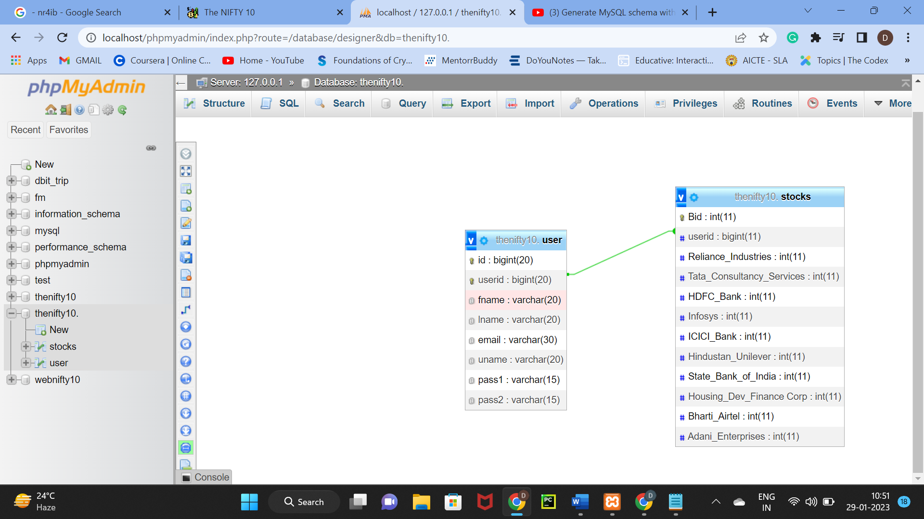

**Chapter 3**

**IMPLEMENTATION**

**3.1 Languages used for implementation**

* HTML: HTML to create a structure of the user interface.
* CSS: CSS to design the layout, to make it visually appealing
* PHP: PHP is a popular programming language that is commonly used to create web applications. It can be used to develop an attendance system that is accessible via a web browser. And also, to handle back-end tasks such as database interactions and user authentication.
* MySQL: MySQL is an open-source RDBMS that uses SQL for data management, it has functionalities like creating, reading, updating and deleting data, it also has advanced functionalities like data encryption, backup and recovery

**3.2 Platform used for implementation**

An Investment/Trading Platform is developed as a web application that can be accessed via a web browser and is typically built using a combination of technologies such as MySQL, PHP, HTML, and CSS. The web application is hosted in a **XAMPP** server and can be accessed by users via a web browser.

Overall, a web-based Investment/Trading Platform can provide user-friendly and secure web-based stock trading platform for Nifty top 10 stocks, with real-time stock information, portfolio management to help users make informed investment decisions and the ability to buy and sell stocks of the top 10 companies listed on the Nifty index in India.

**3.3 SQL Commands and Queries**

1. **Inserting Buying Data into Data Base:**

<?php

session_start();

include("connection.php");

include("functions.php");

$con = mysqli_connect('localhost','root','','thenifty10.');

$user_data = check_login($con);

if($_SERVER['REQUEST_METHOD'] == "POST")

{

$userid = $_SESSION['userid'];

$Reliance_Industries = $_POST['Reliance_Industries'];

$Tata_Consultancy_Services = $_POST['Tata_Consultancy_Services'];

$HDFC_Bank = $_POST['HDFC_Bank'];

$Infosys = $_POST['Infosys'];

$ICICI_Bank = $_POST['ICICI_Bank'];

$Hindustan_Unilever = $_POST['Hindustan_Unilever'];

$State_Bank_of_India = $_POST['State_Bank_of_India'];

$Housing_Dev_Finance_Corp = $_POST['Housing_Dev_Finance_Corp'];

$Bharti_Airtel = $_POST['Bharti_Airtel'];

$Adani_Enterprises = $_POST['Adani_Enterprises'];

$check =" select * from `stocks` where `userid` = '$userid'" ;

$checkk = mysqli_query($con,$check);

if(mysqli_num_rows($checkk) != 0)

{

$Update = " UPDATE `stocks`

SET `Reliance_Industries` = `Reliance_Industries`+'$Reliance_Industries'

WHERE `userid`= '$userid' " ;

mysqli_query($con , $Update);

$Update1 = " UPDATE `stocks`

SET `Tata_Consultancy_Services`= `Tata_Consultancy_Services`+'$Tata_Consultancy_Services'

WHERE `userid`= '$userid' " ;

mysqli_query($con , $Update1);

$Update2 = " UPDATE `stocks`

SET `HDFC_Bank` = `HDFC_Bank`+'$HDFC_Bank'

WHERE `userid`= '$userid' " ;

mysqli_query($con , $Update2);

$Update3 = " UPDATE `stocks`

SET `Infosys` = `Infosys`+'$Infosys'

WHERE `userid`= '$userid' " ;

mysqli_query($con , $Update3);

$Update4 = " UPDATE `stocks`

SET `ICICI_Bank` = `ICICI_Bank`+'$ICICI_Bank'

WHERE `userid`= '$userid' " ;

mysqli_query($con , $Update4);

$Update5 = " UPDATE `stocks`

SET `Hindustan_Unilever`= `Hindustan_Unilever`+'$Hindustan_Unilever'

WHERE `userid`= '$userid' " ;

mysqli_query($con , $Update5);

$Update6 = " UPDATE `stocks`

SET`State_Bank_of_India`= `State_Bank_of_India`+'$State_Bank_of_India'

WHERE `userid`= '$userid' " ;

mysqli_query($con , $Update6);

$Update7 = " UPDATE `stocks`

SET`Housing_Dev_Finance_Corp`= `Housing_Dev_Finance_Corp`+'$Housing_Dev_Finance_Corp'

WHERE `userid`= '$userid' " ;

mysqli_query($con , $Update7);

$Update8 = " UPDATE `stocks`

SET `Bharti_Airtel` = `Bharti_Airtel`+'$Bharti_Airtel'

WHERE `userid`= '$userid' " ;

mysqli_query($con , $Update8);

$Update9 = " UPDATE `stocks`

SET `Adani_Enterprises` = `Adani_Enterprises`+'$Adani_Enterprises'

WHERE `userid`= '$userid' " ;

mysqli_query($con , $Update9);

header("Location: mainportal.php");

die;

}

else{

$query = " INSERT INTO `stocks` ( `userid`, `Reliance_Industries`, `Tata_Consultancy_Services`, `HDFC_Bank`, `Infosys`, `ICICI_Bank`, `Hindustan_Unilever`, `State_Bank_of_India`, `Housing_Dev_Finance Corp`, `Bharti_Airtel`, `Adani_Enterprises`)

VALUES ( '$userid', '$Reliance_Industries', '$Tata_Consultancy_Services', '$HDFC_Bank', '$Infosys', '$ICICI_Bank' , '$Hindustan_Unilever',$State_Bank_of_India','$Housing_Dev_Finance_Corp', '$Bharti_Airtel', '$Adani_Enterprises')";

mysqli_query($con, $query);

header("Location: mainportal.php");

die;

}

}?>

1. **Inserting Selling Data into Data Base:**

<?php

session_start();

include("functions.php");

$id= $_SESSION['userid'];

include("connection.php");

$sql="SELECT * FROM stocks WHERE userid='$id'";

$res=mysqli_query($con,$sql);

while($row=mysqli_fetch_assoc($res)){

$Reliance_Industries=$row['Reliance_Industries'];

$Tata_Consultancy_Services=$row['Tata_Consultancy_Services'];

$HDFC_Bank=$row['HDFC_Bank'];

$Infosys = $row['Infosys'];

$ICICI_Bank = $row['ICICI_Bank'];

$Hindustan_Unilever = $row['Hindustan_Unilever'];

$State_Bank_of_India = $row['State_Bank_of_India'];

$Housing_Dev_Finance_Corp = $row['Housing_Dev_Finance_Corp'];

$Bharti_Airtel = $row['Bharti_Airtel'];

$Adani_Enterprises = $row['Adani_Enterprises'];

}

$Reliance = $_POST['Reliance_Industries'];

$Tata = $_POST['Tata_Consultancy_Services'];

$HDFC= $_POST['HDFC_Bank'];

$infosys = $_POST['Infosys'];

$ICICI = $_POST['ICICI_Bank'];

$Hindustan = $_POST['Hindustan_Unilever'];

$State_Bank = $_POST['State_Bank_of_India'];

$Housing_Dev = $_POST['Housing_Dev_Finance_Corp'];

$Airtel = $_POST['Bharti_Airtel'];

$Adani = $_POST['Adani_Enterprises'];

If ($Reliance <= $Reliance_Industries && $Tata <= $Tata_Consultancy_Services && $HDFC <= $HDFC_Bank && $infosys <= $Infosys && $ICICI <= $ICICI_Bank

&& $Hindustan <= $Hindustan_Unilever && $State_Bank <= $State_Bank_of_India && $Housing_Dev <= $Housing_Dev_Finance_Corp && $Airtel <= $Bharti_Airtel && $Adani <= $Adani_Enterprises)

{

$Update = " UPDATE `stocks`

SET `Reliance_Industries` = $Reliance_Industries - $Reliance

WHERE `userid`= $id " ;

mysqli_query($con , $Update);

$Update1 = " UPDATE `stocks`

SET `Tata_Consultancy_Services` = $Tata_Consultancy_Services - $Tata

WHERE `userid`= $id " ;

mysqli_query($con , $Update1);

$Update2 = " UPDATE `stocks`

SET `HDFC_Bank` = $HDFC_Bank - $HDFC

WHERE `userid`= $id " ;

mysqli_query($con , $Update2);

$Update3 = " UPDATE `stocks`

SET `Infosys` = $Infosys - $infosys

WHERE `userid`= $id " ;

mysqli_query($con , $Update3);

$Update4 = " UPDATE `stocks`

SET `ICICI_Bank` = $ICICI_Bank-$ICICI

WHERE `userid`= $id " ;

mysqli_query($con , $Update4);

$Update5 = " UPDATE `stocks`

SET `Hindustan_Unilever` = $Hindustan_Unilever - $Hindustan

WHERE `userid`= $id " ;

mysqli_query($con , $Update5);

$Update6 = " UPDATE `stocks`

SET `State_Bank_of_India` = $State_Bank_of_India - $State_Bank

WHERE `userid`= $id " ;

mysqli_query($con , $Update6);

$Update7 = " UPDATE `stocks`

SET `Housing_Dev_Finance_Corp` = $Housing_Dev_Finance_Corp - $Housing_Dev

WHERE `userid`= $id " ;

mysqli_query($con , $Update7);

$Update8 = " UPDATE `stocks`

SET `Bharti_Airtel` = $Bharti_Airtel - $Airtel

WHERE `userid`= $id " ;

mysqli_query($con , $Update8);

$Update9 = " UPDATE `stocks`

SET `Adani_Enterprises` = $Adani_Enterprises - $Adani

WHERE `userid`= $id " ;

mysqli_query($con , $Update9);

header("Location: holdings.html");

die;

}

else{

echo "Enter correct values.";

header("Location: profile.html");

die;

}

?>

1. **To logout from the user**

<?php

session_start();

if(isset($_SESSION['userid']))

{

unset($_SESSION['userid']);

}

header("Location: index.html");

die;

**3.4 Output Testing**

1. **Created the individual login for each student and Rectified the bug in the student SignUp Form:**

<?php

session_start();

include("connection.php");

include("functions.php");

if($_SERVER['REQUEST_METHOD'] == "POST")

{

//something was posted

$fname = $_POST['fname'];

$lname = $_POST['lname'];

$email = $_POST['email'];

$uname = $_POST['uname'];

$pass1 = $_POST['pass1'];

$pass2 = $_POST['pass2'];

if(!empty($uname) && !empty($pass1) && !is_numeric($uname))

{

$userid = random_num(20);

$query = " INSERT INTO `user` (`userid`, `fname`, `lname`, `email`, `uname`, `pass1`, `pass2`) VALUES ('$userid', '$fname', '$lname', '$email', '$uname', '$pass1', '$pass2')";

mysqli_query($con, $query);

header("Location: login.php");

die;

}

else

{

echo "Please enter some valid information!";

}

}

?>

1. **Login Form:**

<?php

session_start();

include("connection.php");

include("functions.php");

if($_SERVER['REQUEST_METHOD'] == "POST")

{

$uname = $_POST['uname'];

$pass1 = $_POST['pass1'];

if(!empty($uname) && !empty($pass1) && !is_numeric($uname))

{

$query = "select * from `user` where `uname` = '$uname' limit 1";

$result = mysqli_query($con, $query);

if($result)

{

if($result && mysqli_num_rows($result) > 0)

{

$user_data = mysqli_fetch_assoc($result);

if($user_data['pass1'] == $pass1)

{

$_SESSION['userid'] = $user_data['userid'];

$_SESSION['fname'] = $user_data['fname'];

header("Location: mainportal.php");

die;

}

}

}

echo "wrong username or password!";

}

else

{

echo "wrong username or password!";

}

}

?>

1. **Displaying the Holdings of the User:**

<?php

session_start();

include("connection.php");

include("functions.php");

$con = mysqli_connect('localhost','root','','thenifty10.');

$user_data = check_login($con);

$userid=$_SESSION['userid'];

$sql = "select * from `stocks` where `userid` = '$userid' " ;

$sqll = mysqli_query($con,$sql);

?>

<?php while($rowss = mysqli_fetch_assoc($sqll)) { ?>

<h2 style="text-align: left">My Stock Holdings</h2>

<h3 style="color:#C58940">Reliance_Industries: <?php echo $rowss['Reliance_Industries'] ?> </h3>

<h3 style="color:#C58940">Tata_Consultancy_Services: <?php echo $rowss['Tata_Consultancy_Services'] ?> </h3>

<h3 style="color:#C58940">HDFC_Bank: <?php echo $rowss['HDFC_Bank'] ?> </h3>

<h3 style="color:#C58940">Infosys: <?php echo $rowss['Infosys'] ?> </h3>

<h3 style="color:#C58940">Hindustan_Unilever: <?php echo $rowss['Hindustan_Unilever'] ?> </h3>

<h3 style="color:#C58940">State_Bank_of_India: <?php echo $rowss['State_Bank_of_India'] ?> </h3>

<h3 style="color:#C58940">Bharti_Airtel: <?php echo $rowss['Bharti_Airtel'] ?> </h3>

<h3 style="color:#C58940">Adani_Enterprises: <?php echo $rowss['Adani_Enterprises'] ?> </h3>

<?php } ?>

**Chapter 4**

**Results**

**4.1 Snapshots**

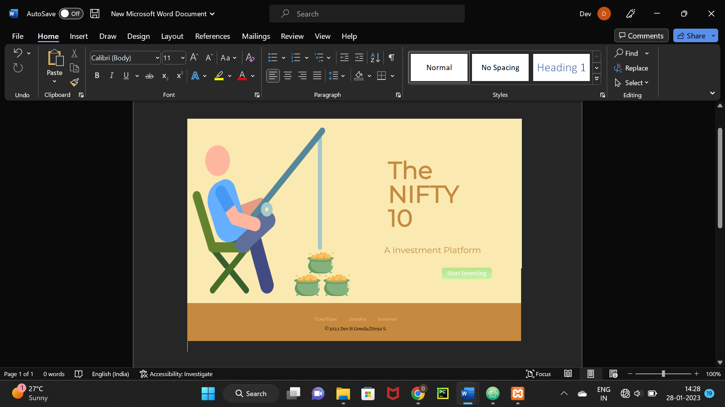

Pic 4.1 Index Page

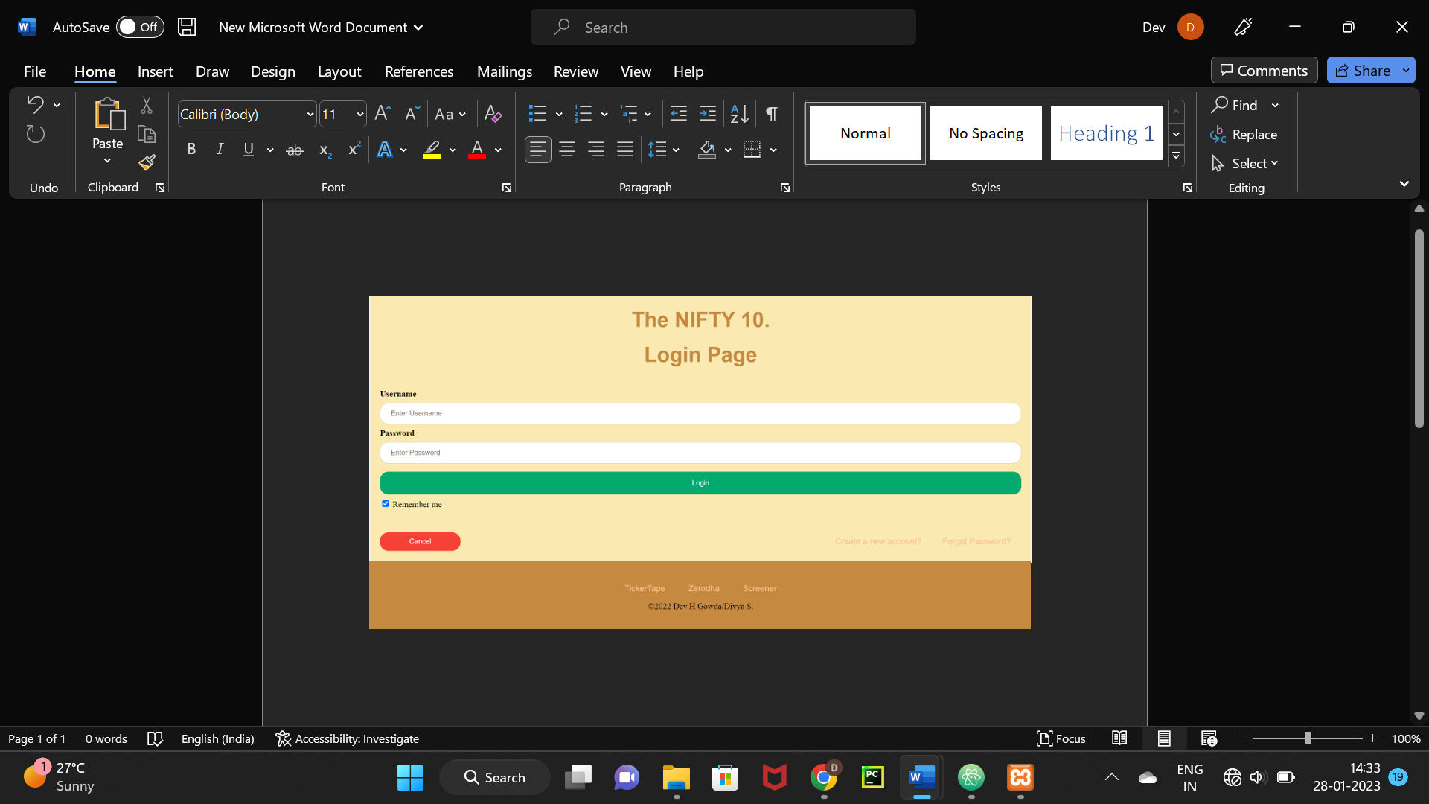

Pic 4.2 Login Page

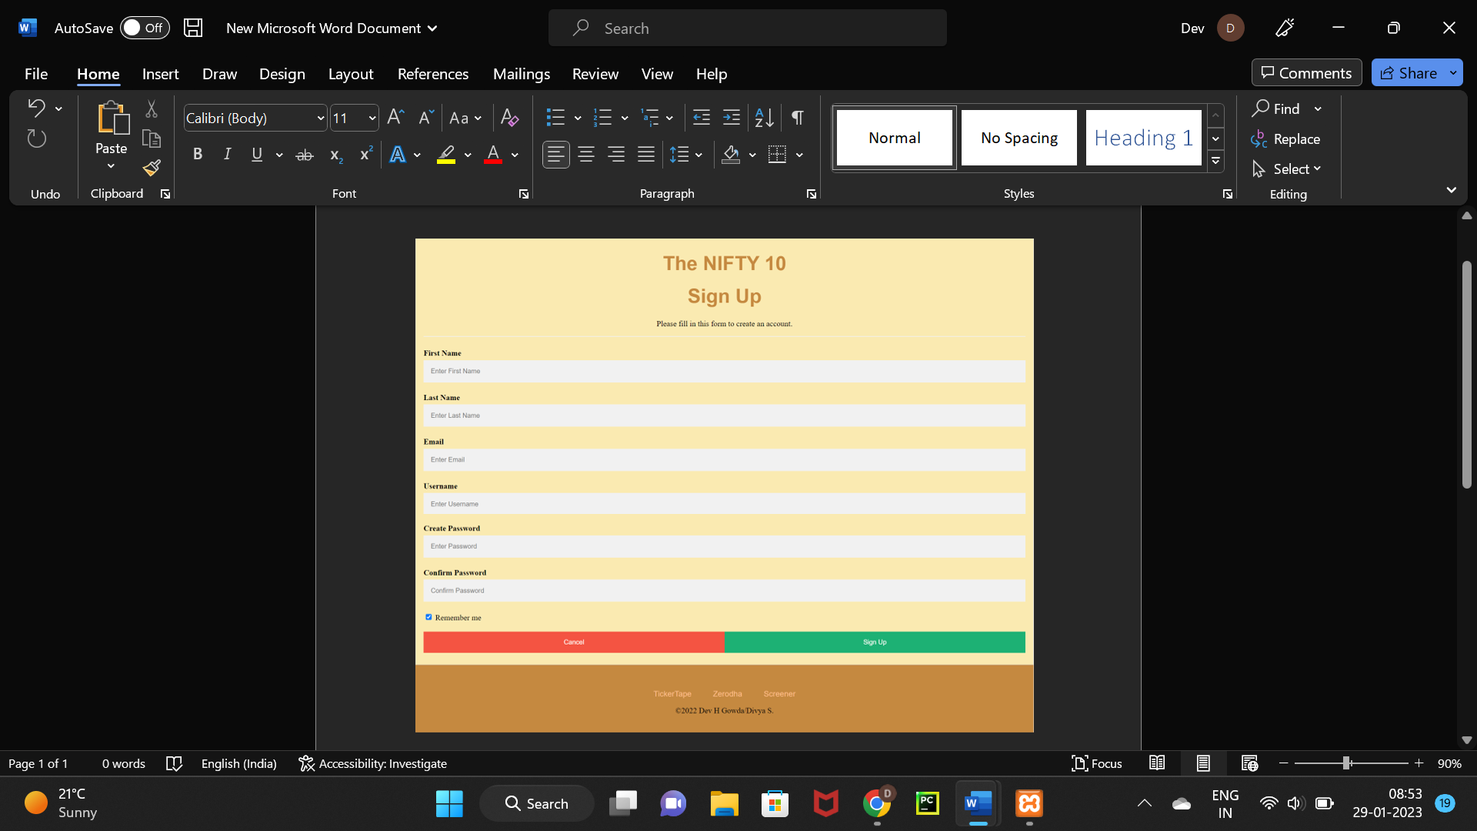

Pic 4.3 SignUp Page

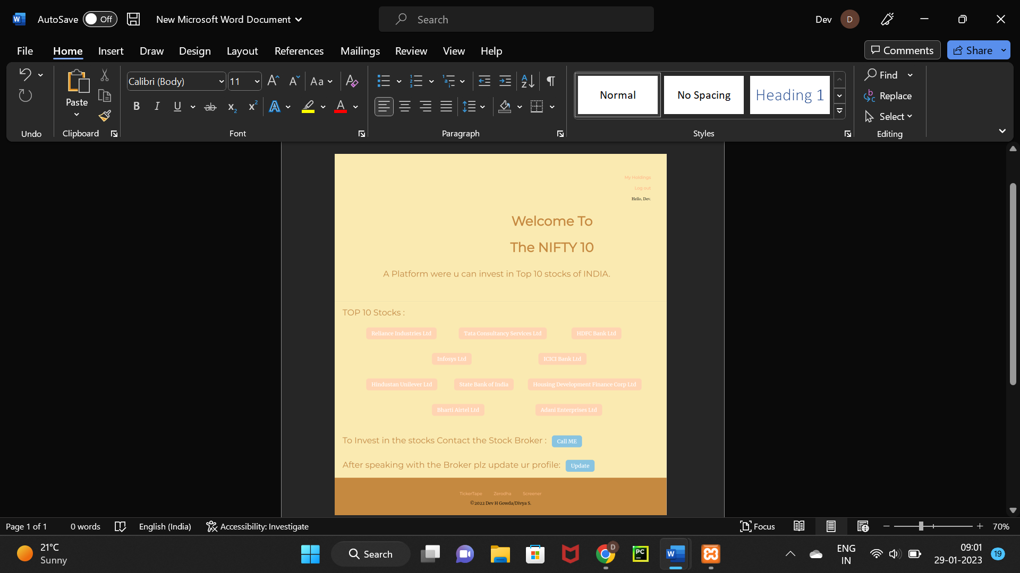

Pic 4.4 Home Page

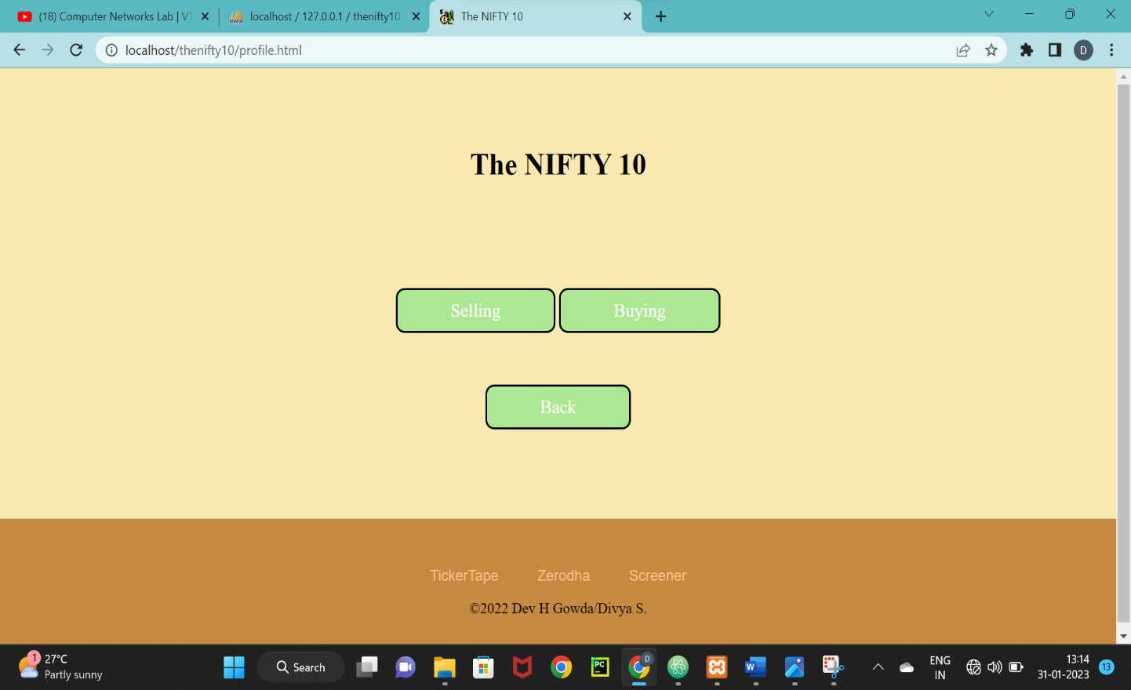

Pic 4.5 Operations Page

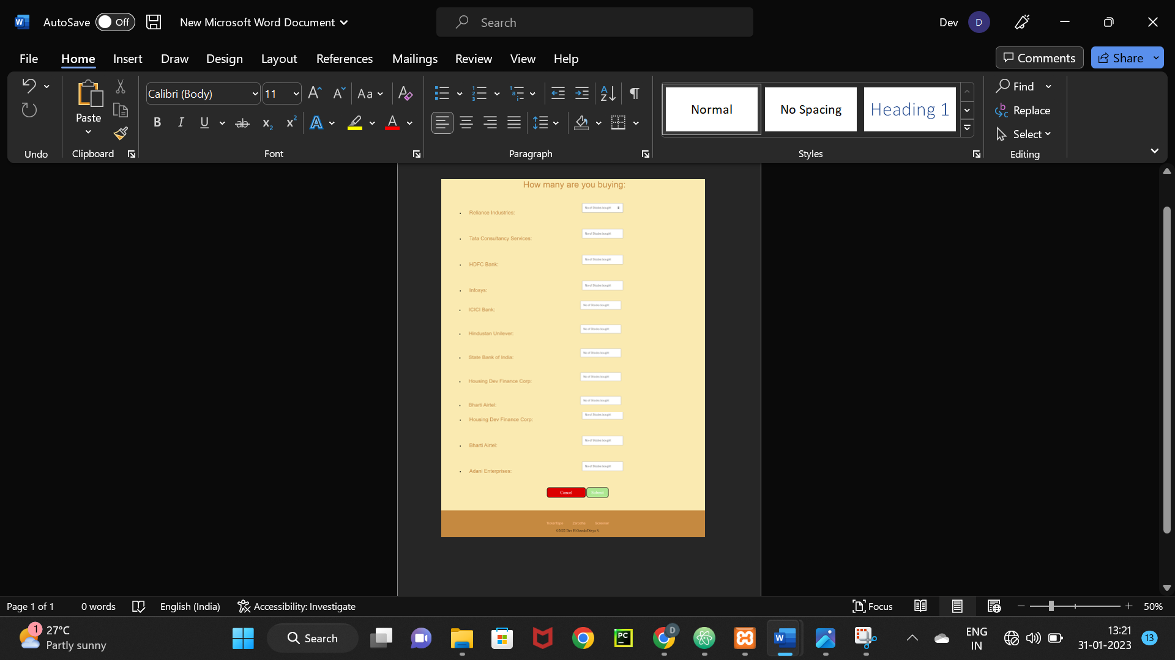

Pic 4.5 Buying Page

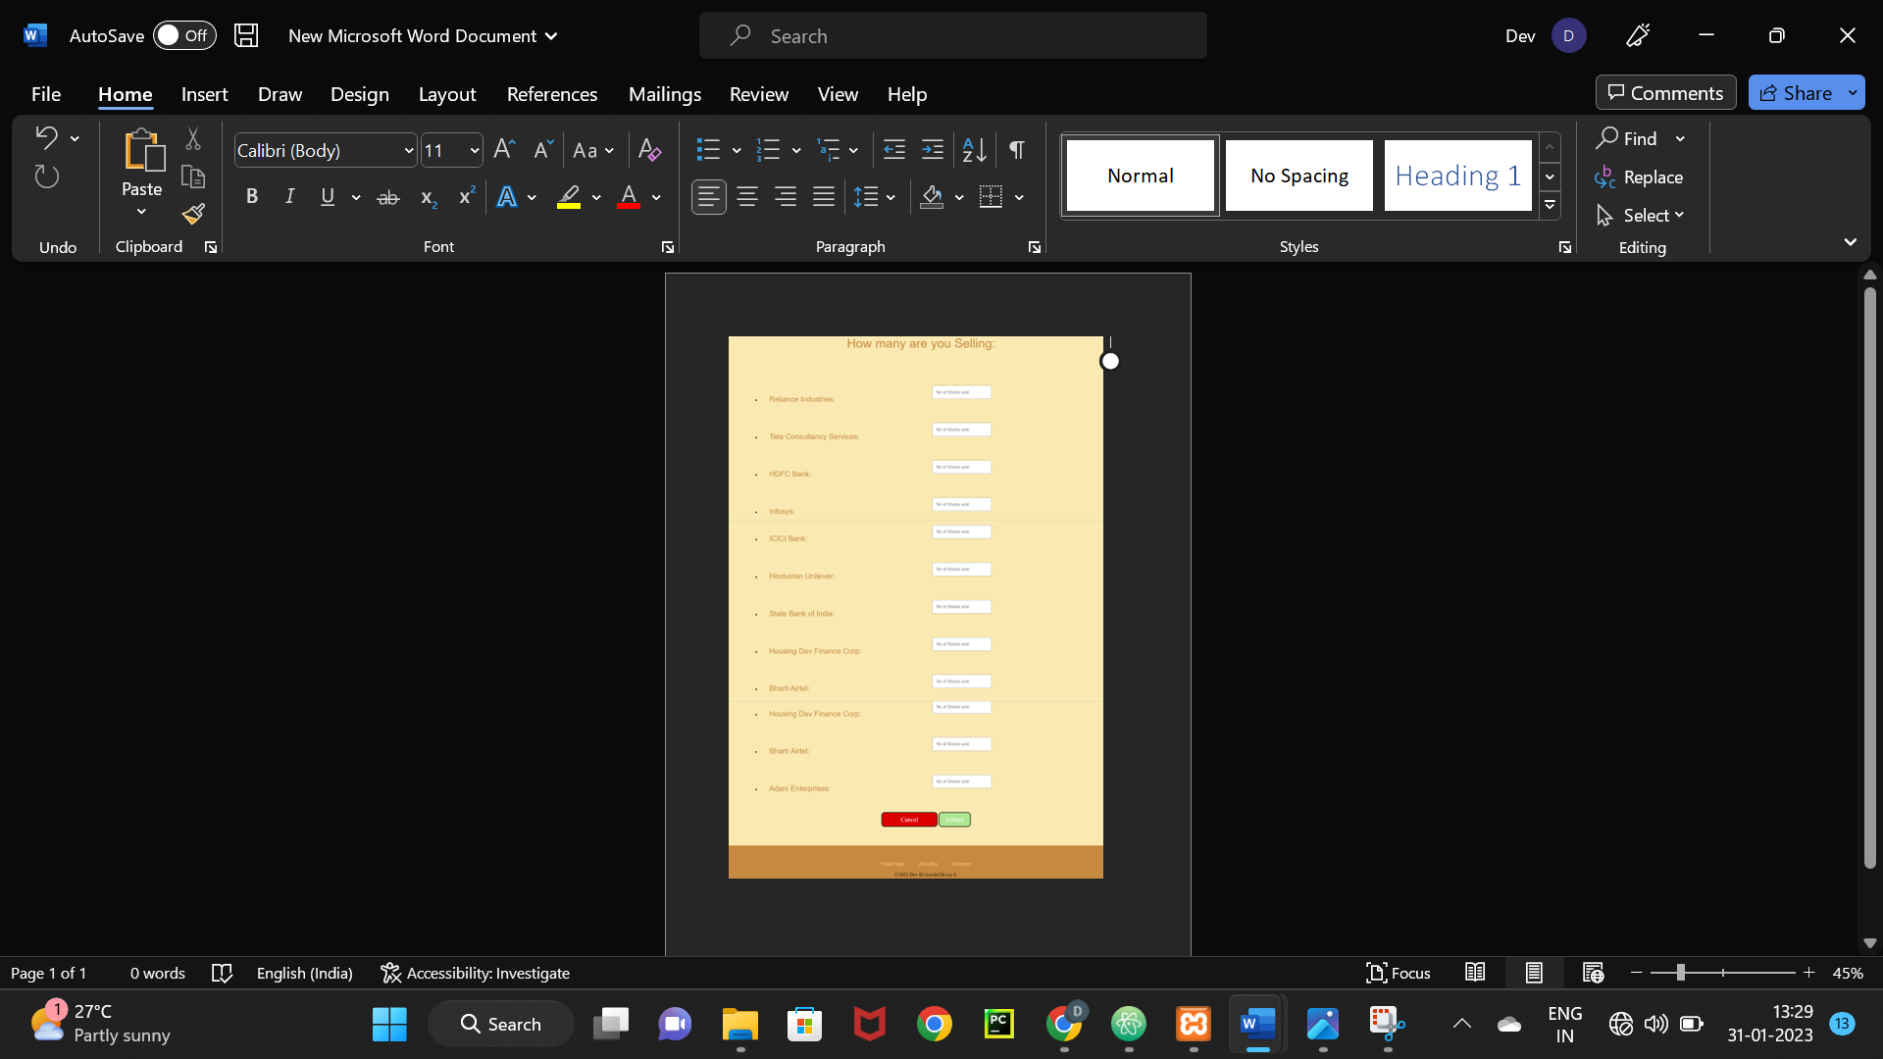Pic 4.5 Selling Page



Pic 4.5 Holdings Page

**Chapter 5**

**Conclusion and Future Enhancement**

* 1. **Conclusion**

The NIFTY 10 web application is a data management tool that provides real-time data and analytics on the top 10 stocks of the Indian stock market. It offers a range of features such as real-time stock prices, historical data, portfolio management, alerts, analysis tools and comparison tools which enables users to make informed decisions and stay updated on the top 10 stocks of India. This application is a valuable resource for anyone looking to invest in the top 10 companies of India and monitor their performance.

* 1. **Future Enhancement**

There are a number of future enhancements that could be made to the NIFTY 10 web application to improve its functionality and usability. Some potential enhancements include:

* Real-time alerts and notifications: The app could be enhanced by adding real-time alerts and notifications. This will enable users to stay informed about important events and changes in the top 10 stocks in real-time and make timely decisions.
* Mobile app version: The app could be enhanced by developing a mobile app version. This will enable users to access the app on-the-go and stay updated on the top 10 stocks even when they are away from their desk.
* Advanced analytics tools: The app could be enhanced by adding advanced analytics tools such as machine learning algorithms and predictive analytics.
* Advanced Portfolio management tools: The app could be enhanced by adding more advanced portfolio management tools such as risk management and tax optimization.

Overall, these enhancements will make the NIFTY 10 web application even more valuable to investors by providing them with more data, analytics, and tools to manage their investments and stay updated on the top 10 stocks of the Indian stock market.

**References**

* <https://www.javatpoint.com/php-tutorial>
* <https://www.w3schools.com/php/>
* <https://www.tutorialspoint.com/php/index.htm>
* <https://chat.openai.com/chat>
* <https://www.tickertape.in/>
* https://www.udemy.com/course/the-complete-web-development-bootcamp/
* Fundamentals of Database Systems, Ramez Elmasri and Shamkant B. Navathe, 7th Edition, 2017, Pearson.
* Database management systems, Ramakrishnan, and Gehrke, 3rd Edition, 2014, McGraw Hill